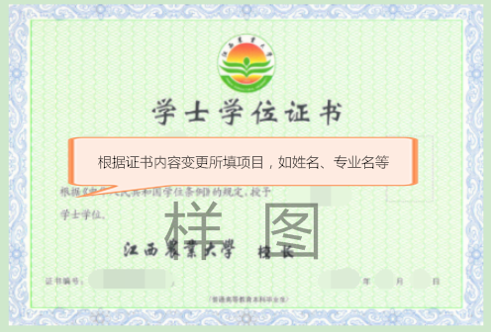

JIANGXI AGRICULTURAL UNIVERSITY

Certificate of Bachelor’s Degree
This is to certify that Mr/Ms Zhang Shan, who was born on June 25, 199X, majored in Agriculture at Jiangxi Agricultural University. After having fulfilled all the requirements of undergraduate coursework, he/she is awarded a Bachelor’s degree of Science/Arts in Agriculture in conformity with the Regulations Concerning the Academic Degrees of the People’s Republic of China.
(主席签字的拼音)
Chairman, Degree Appraisal Committee of
Jiangxi Agricultural University
Certificate Number: 1041042017XXXXXX Date: July 10th, 2017

